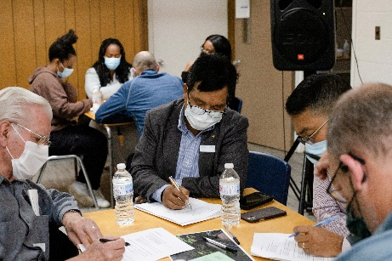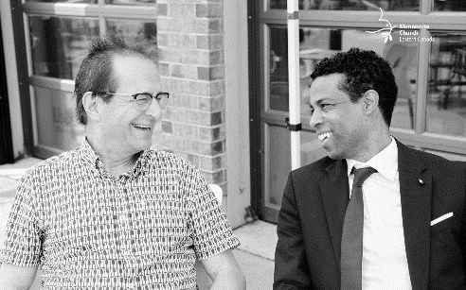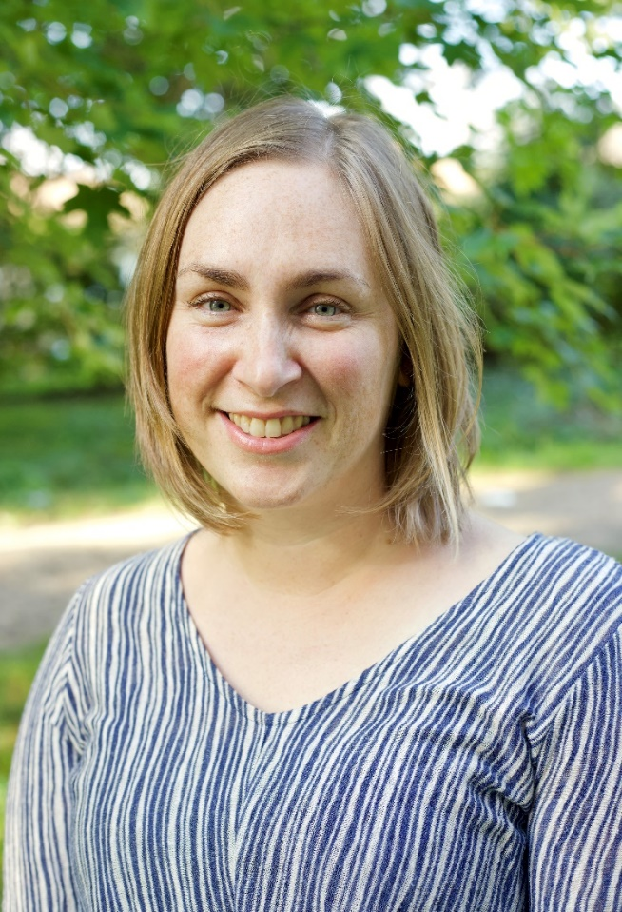

**Fall Courageous Imagination gatherings in Leamington, Niagara, Kitchener, Toronto, Ottawa, Montreal and Zoom.**

**Mentoring relationships are an important part of Transitioning into Ministry – Pastors Jim and Jonathan**

Hello MCEC!

I am so grateful to be a part of the MCEC community of faith with you. I continue to be amazed by the resiliency and faithfulness of MCEC congregations as together we extend the peace of Jesus Christ in our neighbourhoods, nationwide as Mennonite Church Canada, and globally.

Over this past year, we have been on a journey listening for God as we build a shared story about who we are and who God is calling us to become. Where is God at work doing new things? What seeds are sprouting around us? Our verse for this time of community discernment is Isaiah 43:19*. I am about to do a new thing; now it springs forth, do you not perceive it? I will make a way in the wilderness and rivers in the desert.*

Through interviews, social media, ten Courageous Imagination podcast episodes, conversation forums and regional gatherings, we gathered input and feedback on new identity and priority statements as we look to where God is calling us together into the future. Each conversation, whether in-person or online, was filled with hopefulness and deep insight. Across our community, we heard a deep desire to be open to transformation by the Spirit, to follow Jesus with costly discipleship as we put our faith into action, and a longing to stay rooted and grounded in scripture, prayer and worship. Our Annual Gathering April 29-30, 2022 will be a significant milestone on our journey as we prayerfully receive and consider the updated identity and mission statements, along with priorities building on the feedback from the Courageous Imagination listening journey.

Please call me or email me. I would love to hear what seeds God is inspiring you and your congregation to plant and nurture, and your prayers for our larger community of faith as a regional and nationwide church body together.

Leah Reesor-Keller  
MCEC Executive Minister | lreesorkeller@mcec.ca

**A Word From Leah Reesor-Keller, Executive Minister**

lreesorkeller@mcec.ca

**MCEC Community of Congregations**

* 99 congregations
* 82 full membership
* 16 provisional membership
* 1 long-term church plant
* Worship in 19 languages

**Supporting Pastors & Congregational Leaders**

* 5 pastors ordained
* 9 pastors licensed
* 13 pastors installed
* 5 Transitioning into Ministry (TiM) graduates
* 40 Admin Day participants from across Canada – online networking day for administrative assistants
* 50 pastors supporting each other through  
  5 online Pastoral Conversations
* Monthly youth leader conversations

**Supporting Congregations**

* Innovate – providing discipleship resourcing to 11 congregations through ReLearning Community and Community of Practice
* Creative Faith: Live youth online Sunday School series – 20-30 participants
* 2 active working groups
  + Truth & Reconciliation
  + Palestine Israel Network

**Congregational Transitions**

* New Provisional Congregations
  + Hiyaw Amalak, Ottawa
  + Ma Destinée, Montreal

**Church Plants**

* Online Resourcing Day for 41 Church Planters focused on Courageous Self-Care
* Active conversations with 40

church plants/congregations

­­