201 - 50 Kent Avenue,
Kitchener ON, N2G 3R1
Telephone: Local 226-476-2500
Toll Free 855-476-2500
Website: www.mcec.ca
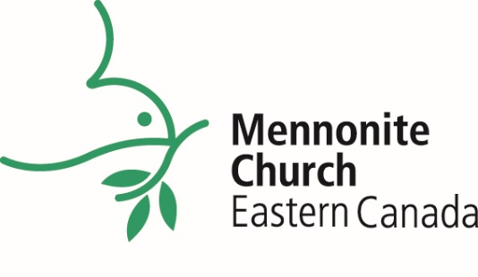

At a Glance

MCEC Community of Congregations
- 105 congregations
- 83 full membership
- 21 provisional membership
- 1 long-term church plant
- Worship in 20 languages
Supporting Pastors & Congregational Leaders
- 5 pastors ordained
- 1 pastor transferred ordination
- 3 pastors licensed
- 36 pastors installed
- 3 Transitioning into Ministry (TiM) graduates
- 41 Admin Day participants from across Canada
- 57 pastors supporting each other through
5 online Pastoral Conversations

Supporting Congregations
- Innovate – resourcing to 13 MCEC congregations
- 3 active working groups
  - Truth & Reconciliation
  - Palestine Israel Network
  - Susatainability

Congregational Transitions
- New Provisional Congregations
  - Centre Béthésda Mennonite de Québec
  - Burning Bush Forest Church
  - Église de Dieu Réparateur des Brèches
  - Église Mennonite Agape
  - Goshen Mennonite Church
  - The Meeting Place
- Full Membership Congregation
  - Meheret Evangelical Church
Church Plants
- 3 Online resourcing days for Church Planters
  - 56 Church Planters in Ancaster (Spring)
  - 44 Church Planters in Montreal (Fall)
  - 24 Church Planters in Toronto (Fall)
2022 IN REVIEW

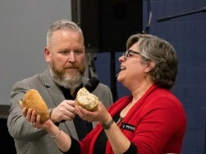
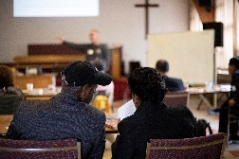
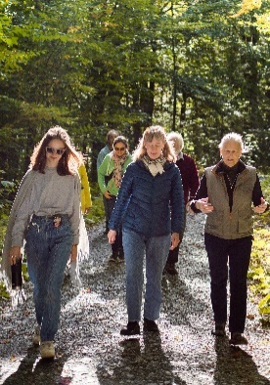

MCEC Delegates Embrace New Identity and Priority Statements
Over 300 people gathered at the 2022 Annual Church Gathering and enthusiastically adopted new identity and priority statements to guide us into who God is calling us to be. Thanks be to God!

Seven congregations and 25 pastors welcomed into MCEC
The new provisional congregations welcomed at the Annual Church Gathering are Centre Béthésda Mennonite de Québec, Burning Bush Forest Church, Église de Dieu Réparateur des Brèches, Église Mennonite Agape, Goshen Mennonite Church and The Meeting Place. Meheret Evangelical Church moved to full membership in MCEC. Twenty-five ministers were installed and welcomed into MCEC as ministering persons with a service of installation and a signing of a covenant of ethics in ministry.

Mennonite Church Canada Gatherings 2022
Twenty-six MCEC delegates attended Mennonite Church Canada’s Gathering 2022, hosted by Mennonite Church Alberta in Edmonton, Alberta, from July 29 to August 1. John Boopalan, Cheryl Bear, Doug Klassen and Kara Carter encouraged and challenged 225 participants in We Declare: what we have seen and heard. 130 youth of Mennonite Church Canada gathered among the tall trees and stunning scenery at Camp Valaqua in Alberta for Amplify Youth Gathering 2022.
Ann Schultz begins as Intentional Interim Executive Team Leader Beginning in January 2023, Ann begins her part-time role with a focus on supporting the MCEC staff team and to developing a broader understanding of and commitment to the strategic priorities 2022-2027. The MCEC executive council now also begins the process of searching for an executive minister, in order to have a permanent executive minister begin in January 2024.

We are a diverse community,
Transformed by the love of God,
Inspired by the hope we find in Jesus,
Called to action by the power of the Holy Spirit.
Top left: Norm Dyck, Mission Minister, and Marilyn Rudy-Froese, Church Leadership Minister, led communion at Annual Church Gathering after welcoming congregations and pastors.
Bottom left: Colin McCartney engaged Church Planters in Toronto during fall resourcing day – Let the Light In.
Right: Montreal Mennonite Fellowship on ecotheology retreat reflected on how they would take of the world.

We come together as a regional church to:
Energize Congregations, Encourage Leaders, Embody God’s Reconciling Ministry

