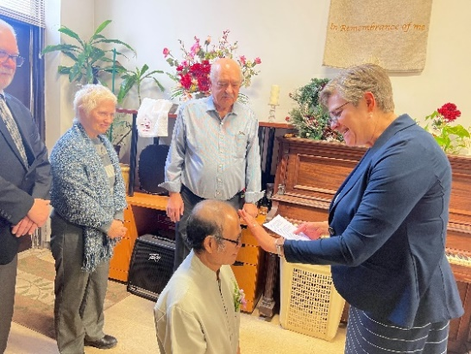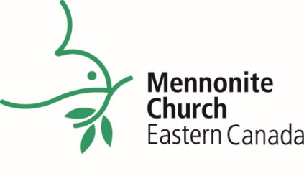

**Left**: Marilyn Rudy Froese, MCEC Church Leadership Minister, anoints Chinda Kommala during his ordination ceremony.

**Middle**: A shocking experience at a junior youth event in Leamington.

**Top**: Anthony Siegrist hired as Executive Minister.

**2024 IN REVIEW**We come together as MCEC toEnergize Congregations | Encourage Leaders |   
Embody God’s Reconciling Ministry

**We celebrate congregations and pastors.**

**108 congregations**

* Welcomed 5 congregations to provisional membership: FreeChurch Toronto; Mennonite Disciples Swahili Church (Ottawa-Gatineau); Rehoboth Inner Healing Church; Shalom Worship and Healing Centre, Guelph; Shalom Worship and Healing Centre, Windsor.
* Congregations Closed - Hawkesville Mennonite Church (June 2024); Agape Fellowship (July 2024). We appreciate the generosity of these congregations and their support of MCEC through their legacy gifts.

**196 pastors serve as congregational pastors, chaplains and in other capacities**

* 14 pastors installed in congregations
* 6 pastors licensed toward ordination
* 3 pastors ordained

**We are inspired by ministry throughout MCEC.**

* At the Annual Church Gathering in Leamington, 236 delegates and congregational leaders were inspired by the hope we find in Jesus as we came together to worship and collaborate in community. We grow, learn and serve best in relationship with others, listening for God together.
* In the area of youth engagement, 150 voices contributed to a research project focused on ways to better engage youth in the church. Alongside our partners, junior youth gatherings in Kitchener and Leamington brought together 144 junior youth and their sponsors for meaningful connection and growth. This effort reflects our commitment to leadership development, intergenerational discipleship, collaborating with our partners to nurture both the current and future generations of the church.
* To encourage leaders of hope, vision and transformation, 39 pastors attended renewing retreats, focused on the seasons of Lent and Advent. Additionally, 50 pastors participated in Healthy Boundary Workshops online, equipping them to maintain healthy boundaries while leading with integrity and care.
* The INNOVATE Ministry concluded after a decade of impactful service. Over the past 10 years, 48 MCEC congregations have participated in discipleship events and workshops, fostering growth and renewal. Additionally, the Transitioning in Ministry (TiM) Program saw the graduation of 5 pastors this year.
* We are privileged to journey alongside congregations during transformative moments, whether it’s through pastoral searches, discernment processes, revitalizing mission, or reimagining facilities. A wonderful example of this is the shared co-ownership journey of Shalom Worship & Healing Centre and First Mennonite Church.
* We celebrate the hiring of Anthony Siegrist as Executive Minister, effective February 1, 2025.

201 - 50 Kent Avenue, Kitchener ON, N2G 3R1 www.mcec.ca

We are grateful for the ongoing support of congregations, pastors and leaders through prayer, time and finances. We continue to grow into the future as a transformed, inspired and called people of God.

**Transformed | Inspired | Called**